Title field – highlight this text and replace with your title

1st Author's Name 2nd Author's Name 3rd Author's Name
Affiliation Affiliation Affiliation
Address Address Address
E-mail Address E-mail Address E-mail Address

SUMMARY

The summary is a short, informative abstract of no more than 200 to 300 words. References should not be cited. The summary should not simply list the topics covered in the paper, but should (1) state the scope and principal objectives of the research, (2) describe the methods used, (3) summarise the results, and (4) state the principal conclusions.

Text of the summary should be 9 pt Times New Roman font, single-spaced and justified. A single line space should be left below the title ‘SUMMARY’. Simply highlight these summary paragraphs and replace with the text of your summary. Leave a single line space above the key words listed below.

Key words: 1 to 5 key words in 9 pt Times New Roman, separated by commas; these will assist in the cross-indexing of the article.

INTRODUCTION

The purpose of the introduction is to tell readers why they should want to read what follows. This section should provide sufficient background information to allow readers to understand and evaluate the paper’s results. The introduction should (1) present the nature and scope of the problem, (2) review the pertinent literature (within reason), (3) describe the method of investigation, and (4) describe the principal results of the investigation.

All text in the main body of the extended abstract should be 9 pt Times New Roman font, single-spaced and justified. Main headings are placed in the centre of the column, in capital letters using 10 pt Times New Roman Bold font. Subheadings are placed on the left margin of the column and are typed in 9 pt Times New Roman Bold font. Full stops should be followed by two spaces.

To enter your introduction, highlight the above paragraphs and replace with your words.

METHOD AND RESULTS

There is flexibility as to the naming of the section (or sections) that provide information on your method and results. The methodology employed in the work must be described in sufficient detail or with sufficient references so that a competent geophysicist could duplicate the results.

Your material should be organised carefully. Include all the data necessary to support your conclusions, but exclude redundant or unnecessary data.

Choose the active voice rather than the passive. Use the first person, not the third person, and do not use "we" when "I" is more appropriate.

Figures and Tables

The results of experiments can be presented as tables or figures. Selective presentation of results is important. Redundancy should be avoided.

Figures may be interspersed within the results section of the extended abstract, or they can be appended to the end of the written text. Figures can be imported from a number of graphical formats. Figures may be black & white or full colour. Note that if figures are to be interspersed within text, they should be no wider than the width of the text column. Larger figures will need to be placed at the end of the abstract where they can extend the full width of the A4 page.

Tables can be created within Microsoft Word. As noted for figures above, if a table is to be placed within the text, it can be no wider than the width of the text column. Larger tables will need to be placed at the end of the abstract.

Figure and tables should be numbered according to the order they are referenced in the paper. Figures and tables should be referred to by their number in the text. When referring to figures and tables in the text, spell out and capitalise the word Figure or Table. All figures and tables must have captions.

Captions

Captions should be explicit enough so that they explain the significance of the figure or table without reference to the text. Details in captions should not be restated in the text. The inclusion of detailed parameters in figure captions can improve the smooth flow of the main text.

Captions should be placed directly beneath the relevant figure or table. The caption should be typed in 9 pt Times New Roman Bold font. Again spell out the word 'Figure' or ‘Table’ in full. An example figure follows.
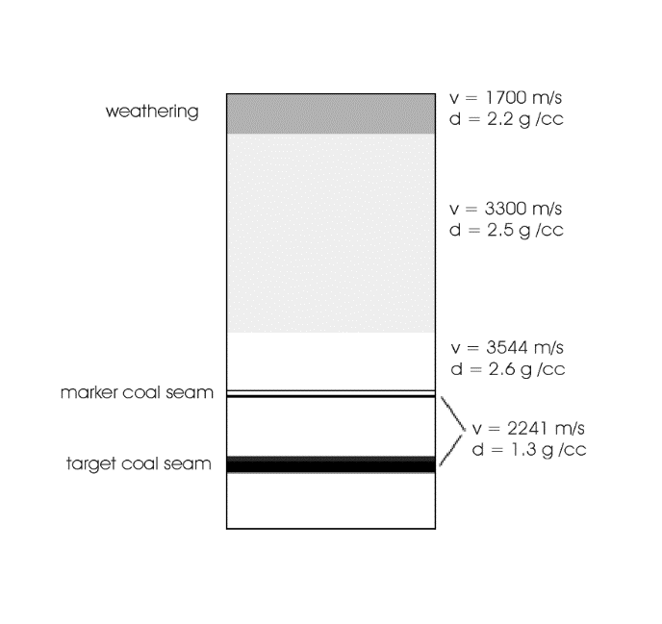
Figure 1. Geological model used as basis for seismic modelling. The vertical extent is 150 m. The velocity (v) and density (d) are shown for each layer.

CONCLUSIONS

This section should include (1) the principles, relationships, and generalisations inferred from the results, (2) any exceptions to, or problems with, these principles, relationships and generalisations, (3) agreements or disagreements with previously published work, (4) theoretical and practical implications of the work, and (5) conclusions drawn.

ACKNOWLEDGMENTS

Acknowledgments are optional. They should acknowledge any significant contributions made by people or organisations to the work presented in the extended abstract.

REFERENCES

Where a reference appears as part of a sentence, it should show the authors’ names, followed by the year of publication in parentheses. This example refers to the work of Hendrick and Hearn (1999). Where the full reference is parenthesised it should appear as follows (Hendrick and Hearn, 1999). When reference is made in the text to work by three or more authors, only the first author’s name should be used, followed by et al.

A list of references must appear at the end of the main body of the text. To be of real value, authors should attempt to only reference material that is readily accessible to the reader.

References should be listed alphabetically by author. Do not abbreviate journal titles. The preferred format is based on that used in Exploration Geophysics. Several examples, for journal articles, conference abstracts, books and theses, follow.

Du, B., 2000, Comparison of crosswell diffraction tomography to Kirchoff migration: Exploration Geophysics, 31, 366-371.

Hendrick, N., and Hearn, S., 1999, Polarisation analysis: What is it? Why do you need it? How do you do it?: Exploration Geophysics, 30, 177-190.

Leaney, W.S., 1990, Parametric wavefield decomposition and applications: 60th Meeting, SEG, San Francisco, Expanded Abstracts, 1097-1100.

Press, W.H., Flannery, B.P., Teukolsky, S.A., and Vetterling, W.T., 1992, Numerical recipes in Fortran77 2nd edition - The art of scientific computing: Cambridge University Press.

Zhou, B., 1988, Crosshole resistivity and acoustic velocity imaging: 2.5-D Helmholtz equation modeling and inversion: Ph.D. Thesis, University of Adelaide.

Note: figures or tables too large to be interspersed with text in column format should be placed here at the end of the paper.

The size limit for a paper in the conference volume is 10 Mbyte.

